**Pizza Sales Analysis Using Power BI**  
  
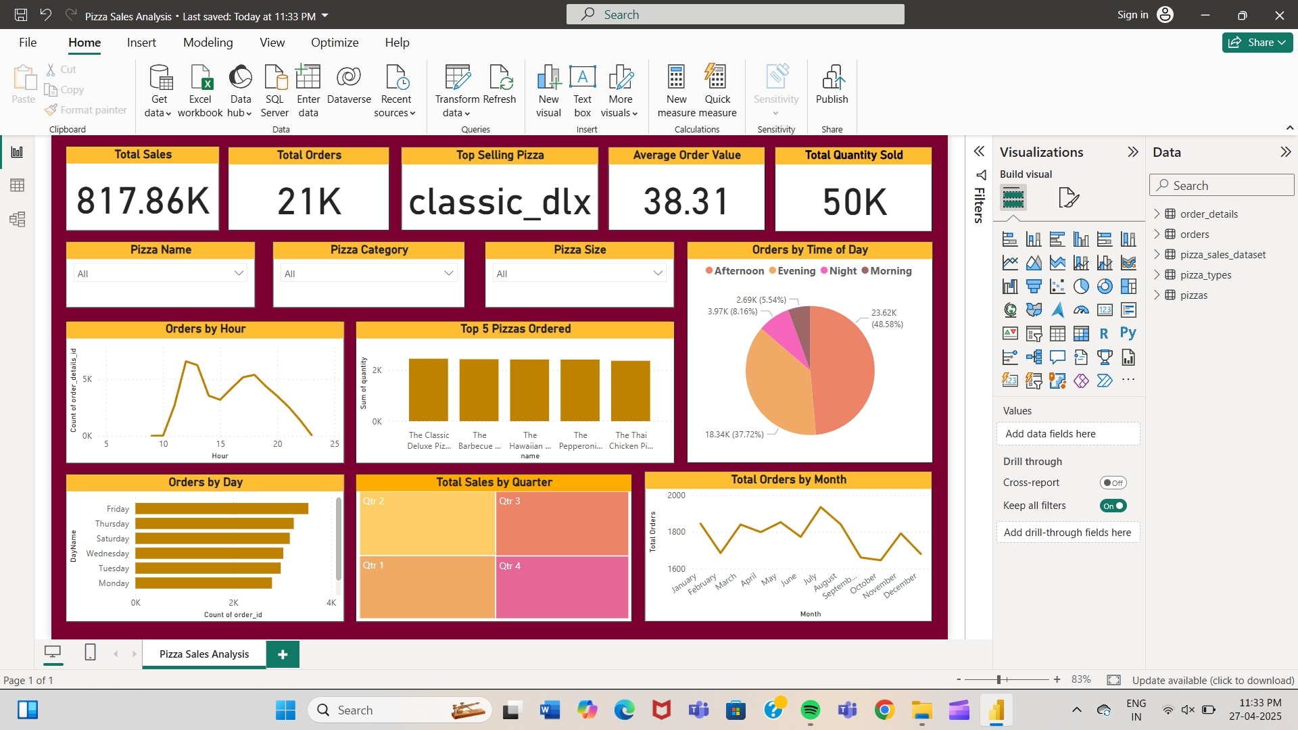

**Project Overview:**

Developed an interactive and visually appealing dashboard in **Power BI** to analyze a pizza company's sales data. The dashboard provides comprehensive insights into key business metrics such as total sales, total orders, top-selling pizzas, customer ordering behaviour, and seasonal trends.

**Objectives:**

* Analyze overall sales performance and identify key revenue drivers.
* Track the most popular pizza types and categories based on sales quantity.
* Understand customer ordering patterns based on time of day, hour, day of the week, and month.
* Provide insights into sales distribution across different quarters of the year.
* Support data-driven decision-making for marketing and inventory planning.

**Key Features:**

* Total Sales, Total Orders, Average Order Value, and Quantity Sold KPIs.
* Identification of the Top Selling Pizza.
* Dynamic Filtering by pizza name, category, and size.
* Orders by Hour line chart to capture peak order times.
* Orders by Time of Day pie chart (Morning, Afternoon, Evening, Night).
* Top 5 Pizzas Ordered bar chart based on quantity sold.
* Orders by Day horizontal bar chart to analyze weekly trends.
* Sales by Quarter heatmap to understand seasonal performance.
* Total Orders by Month trend line chart to visualize monthly sales fluctuations.
* Designed with user-friendly navigation and a clean, engaging UI theme.

**Tools & Technologies Used:**

* Power BI Desktop
* Data Modeling (Multiple Tables: Orders, Pizza Types, Pizza Sales Dataset, Pizzas)
* DAX (Data Analysis Expressions) for calculations and KPIs
* Data Visualization best practices